# OFFICIAL COORDINATION REQUEST FOR NON-ROUTINE OPERATIONS AND MAINTENANCE

**COORDINATION TITLE-**16BON120 CI Count Station Crowder Repair

**COORDINATION DATE-** 05 December 2016

**PROJECT-** BON

# RESPONSE DATE- 10 November 2016 (FPOM meeting)

**Description of the problem-**

The crowder mechanism at the Cascades Island count station has a piece of wood debris lodged underneath it. This debris impeded the crowders movement, and cycling the crowder tripped the circuit breaker. The crowder is not operational until the wood is removed. An operational crowder is necessary for the window cleaning mechanism to work. The location is such that despite numerous attempts, the wood cannot be removed with the area fully watered up. This is due to a lack of access and high water velocity through the counting slot. Thus, we need to temporarily pinch down the Cascades Island fishway exit and Fish Valve 5-9 to bring the water level down in order to do the work. We will keep the water level 1-2’ deep in the serpentine section so that fish salvage is not necessary. We anticipate that the ladder below the work area will slowly go to approximately orifice flow.

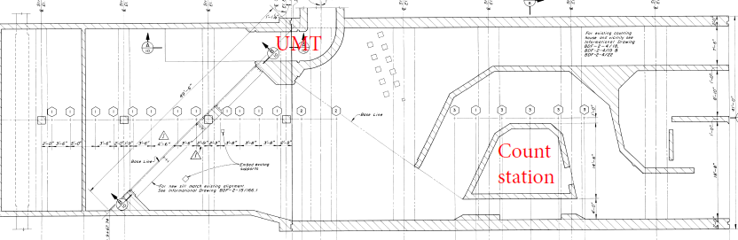

Woody debris location (exact)

Crowder location

Figure 1. Cascades Island fish ladder section where crowder (red circle) and debris (blue circle) are.

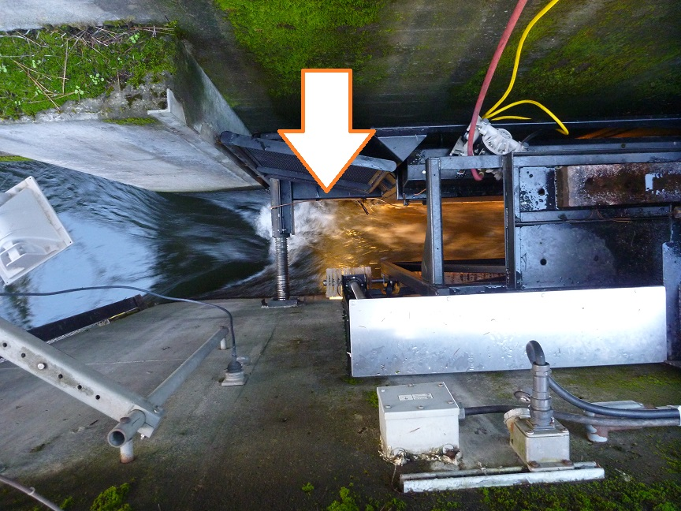

Figure 2. Overhead view of the upstream side Cascade Island crowder. The arrow points to the location of the jam.

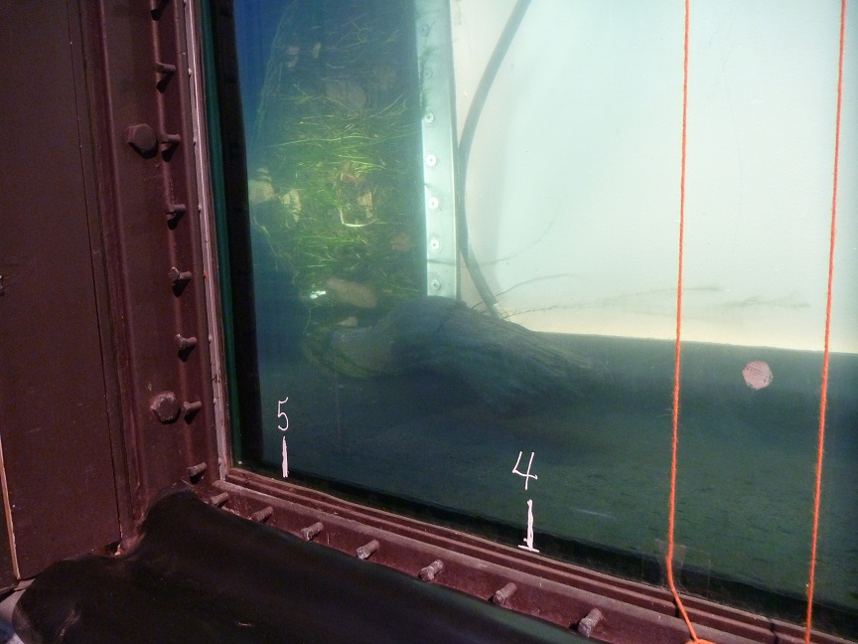

Figure 3. The piece of wood at fault.

# Type of outage required-

None

# Impact on facility operation-

Fishway water levels will be reduced in the Cascades Island ladder.

# Dates of impacts/repairs-

12 December 2016. No impact to other Bonneville operations.

# Length of time for repairs-

Three hours or less.

# Expected impacts on fish passage-

Fish will not be able to exit the from the CI ladder during the work period. Once the operation begins, and the water level decreases in the serpentine section, some fish may begin to back down the ladder. This will result in their passage being delayed until the work is done and the exit opened. Passage is currently low, with Cascade Island averaging about 5 fish per day, mostly Steelhead.

As a result of this analysis, we anticipate that the proposed action will result in negligible impact to listed species.

Table 1. Total daily salmonid passage for 10 year period from 2005-2015 on 12   
December at Bonneville Dam.

|  |  |  |  |
| --- | --- | --- | --- |
| Date | Chinook | Coho | Steelhead |
| 12-Dec-15 | 12 | 15 | 60 |
| 12-Dec-14 | 3 | 7 | 30 |
| 12-Dec-13 | 0 | 0 | 2 |
| 12-Dec-12 | 1 | 0 | 18 |
| 12-Dec-11 | 1 | 0 | 47 |
| 12-Dec-10 | 3 | 11 | 30 |
| 12-Dec-09 | 0 | -1 | 22 |
| 12-Dec-08 | 0 | 1 | 21 |
| 12-Dec-07 | 1 | 0 | 43 |
| 12-Dec-06 | 1 | 1 | 49 |
| 12-Dec-05 |  |  |  |

Table 1. Daily fish passage at Cascades Island for December 2016 at Bonneville Dam.

|  |  |  |  |
| --- | --- | --- | --- |
| Date | Chinook | Coho | Steelhead |
| 01-Dec-16 | 3 | 0 | 1 |
| 02-Dec-16 | 1 | 0 | 2 |
| 03-Dec-16 | 1 | 0 | 4 |
| 04-Dec-16 | 0 | 0 | 3 |
| 05-Dec-16 | 0 | 0 | 5 |

# Comments from agencies Final results

Please email or call with questions or concerns. Thank you,

Erin

Erin Kovalchuk

NWP Operations Division Fishery Section Columbia River Coordination Biologist 541-298-7405

[Erin.H.Kovalchuk@usace.army.mil](mailto:Erin.H.Kovalchuk@usace.army.mil)